**Round 2**

Round 2 Experiment1: Time Dilation

1. **Story Outline**

The experiment involves a spaceship travelling in space freely with a clock present on the spaceship as well as Earth. In the Einstein’s special theory of relativity, the moving clock is found to run slower than a clock at rest does.

We now know that rates of time actually run differently depending on **relative motion**, so that time effectively passes at different rates for different observers travelling at different speeds, an effect known as **Time Dilation**. Thus, two synchronized clocks will not necessarily stay synchronized if they move relative to each other.

It should be noted that, although a spaceship travelling at close to the speed of light would take approximately 100,000+ years to reach a distant star 100,000 light years away as judged by clocks on Earth, the astronaut in the spaceship might hardly age at all as he travels across the galaxy. This characteristic of relativistic time has therefore spawned much discussion of the possibility of **time travel**

1. **Story**
   1. **Set the visual stage discussion:**
2. **Construction of the set-up**

For better visualization, a simulator is provided. Time Dilation is always taught in a theoretical manner but there is always a need of some physical significance. Since performing this experiment in real life is not feasible because of cost issues, a simulation can always act as the best possible alternative. A space ship will be present that is set to move freely in the space. Two clocks will be used in the set-up. One will be placed on the spaceship which measures time for the moving inertial frame and the other will be placed on Earth that measures time on rest frame.

* 1. **Set User Objectives & Goals:**

1. The prime objective of this experiment is to understand the theory of Time Dilation.
2. To use the spaceship as a means of transport and understand the difference between two inertial frames.
3. To let the spaceship move in the free space.
4. To note the difference in proper time and dilated time in two different frame of reference.
5. Compare the observed values.
6. Observe the graph plotted between dilated time and velocity of a moving frame of reference.
7. Reach the conclusion.
   1. **Set the pathway activities:**
8. The set-up consists of a spaceship which is in space, two clocks kept on earth and space respectively.
9. Input fields to get Time and Velocity of spaceship.
10. There would be a ‘Start’ button which will start the engine of ship and it will move.
11. You can take readings at any time by pressing “Record Observations”. Minimum 3 and maximum 10 observations are allowed.
12. “Graph” button allows you to plot a graph between dilated time and velocity of a moving frame of reference.
13. “Theoretical formula” gives the observed value of dilated time (non-proper time).
    1. **Set Challenges and Questions/Complexity/Variations in Questions:**
14. A clock is moving with the speed of light c relative to a stationary observer. The observer feels that the clock is
15. Fast
16. Slow
17. Completely stopped
18. None of these
19. Which one is the following is an invariant under Galilean transformations?
20. Velocity
21. Acceleration
22. Momentum
23. None of these
24. An inertial frame of reference is one which
25. Remains at absolute rest
26. Remains at absolute motion
27. Does not accelerate
28. Is attached to an observer
29. The apparent length of a meter stick, as measured by an observer at rest when the stick is moving long its length with a speed (c will be
30. 0.1 m
31. 0.3 m
32. 0.5 m
33. 0.7 m
34. The rest mass of a photon of energy *E* is
35. 0
36. Infinity
37. Ec2
38. E/c2
    1. **Allow pitfalls:**
39. When speed of spaceship is equal to speed of light, the clock will completely stopped.
40. When speed of spaceship is greater than speed of light, measurements cannot be taken, as we know that no object can go faster than velocity of light.
41. MCQ questions have to be answered to enable simulator buttons.

**2.6 Conclusion**

The difference between two inertial frames has been made clear. Difference of time has been observed for both the clocks, one placed on the moving frame while one on the rest frame.

The clock placed on the rest frame moves faster than the one placed on the moving frame.

* 1. **Equations/Formula**

1. 
2.  is the time observed by an observer relative to rest observer.
3.  is the time observed by an observer which is at rest (in which event takes place)
4.  is the relative speed of spacecraft w.r.t earth
5.  is the speed of light.
6. **Flowchart**

Simulator screen will be displayed

Will ask least count of velocity for graph

Click on Submit button of least count

Press “Graph” to plot graph. Press “Theoretical Value” to get the formula based dilated time.

Select time period (years, months, days, minutes, seconds) from the list

Enter numeric value of time period from 0 to 1 (range)

Enter velocity of particle to set the particle moving with relativistic speed

from (0 to 1) times 3×108 sec

**Wrong Answer**

A clock is moving with a speed of light ‘c’ relative to a stationary observer the observer feels that the clock is:-

1. Fast b) Slow c) Completely stop

If option c) is correct, then yes and go next button, if no then go to last button

**User will pass through the pitfall**

**Question**

Correct Answer

**Now user will click on record observation to record readings for the graph**

Now a table will be formed having data sets of time and velocity on x and y axis

**User will pass through the pitfall**

Refer to Einstein’s special theory of relativity

If User exceeds v > c, Observations can’t be taken because it is not possible practically

**Question Hint**

Now user will plot a graph from observation table (**Dilated time Vs velocity**)

If user understands theory of Time Dilation, then user will be able to frame answers of given question

Click on Conclusion Button

**If answered wrong**

**Questions**

1. Which of these statements are true for Lorentz transformation equation:-

**a)** For non-relativistic motion only  **b)** For relativistic motion only **c)** For both **d)** None Of these

2. Which of the following is true for time dilation.

a) t’=t-(vx/c2)/√(1-v2/c2) **b)** t’=t **c)** Both are correct **d)** None of these

3. Relativistic equations for time dilation hold true at**a)** speeds near that of light **b)** everyday low speeds **c)** all speeds **d)** only approximately

4. Which of the following refers to the slowing of time at high speeds?

**a)** time dilation **b)** time expansion **c)** time contraction **d)** space-time

**4. Mind-map**

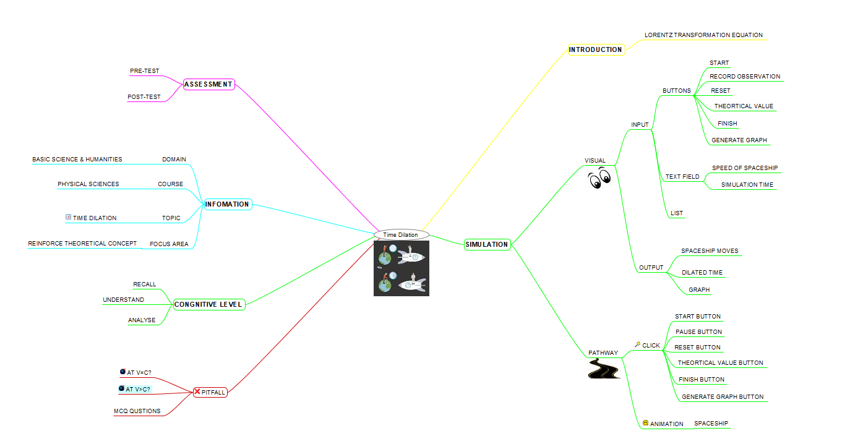

1. **Storyboard**







